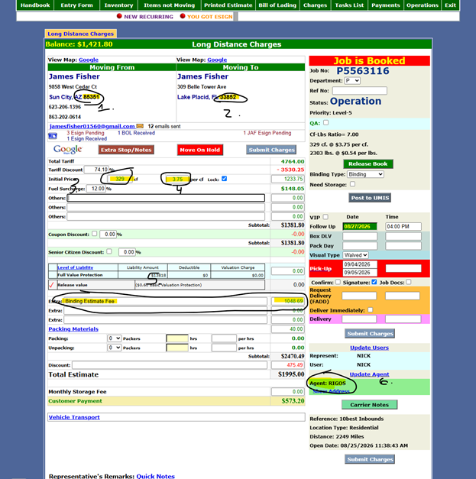
1. Pickup Zone
2. Delivery Zone
3 & 4 Relate to Service in Column E. The service should be marked as Linehaul. 3 is Rule and 4 is New Rule
5 Relate to Service in Column E. The service should be Additional Services. Rule is Binding Estimate Fee. 5 the dollar amount is New Rule.
6. Carrier Assigned. I will provide Sheet reference for agent acronym with full name and DOT number
Effective Date will be the date the info is submitted through the extension.
The two different services will need to be two different entries on the sheet. Remaining info is the same ie for above will have these two entries if ran:

Effective Date: 8/28/2026
Pickup Zone: 85351
Delivery Zone: 33852
Service: Linehaul
Rule: 301 to 500 cf
New Rule: $3.75 per cf.
Carrier: RIGOS DELIVERY MOVING AND STORAGE INC 2824890

AND

Effective Date: 8/28/2026
Pickup Zone: 85351
Delivery Zone: 33852
Service: Additional Services
Rule: Binding Estimate Fee
New Rule: $1048.69
Carrier: RIGOS DELIVERY MOVING AND STORAGE INC 2824890

